**Office Scripts Excel Online Translation Functionality**

See, also, the YouTube video for this demo : <https://youtu.be/I6gUjeBDKD8>

Excel Online is without a Translate function similar to that of the GoogleSheet’s ***GoogleTranslate*** function. So, how do we replicate this in Excel Online? It is easier than you think. Office Scripts, at this time, does not provide for User Defined Formula creation. But together with Power Automate it can be done!

Here is how Google Sheets does it. You have to specify the “to” and “from” languages and the text.

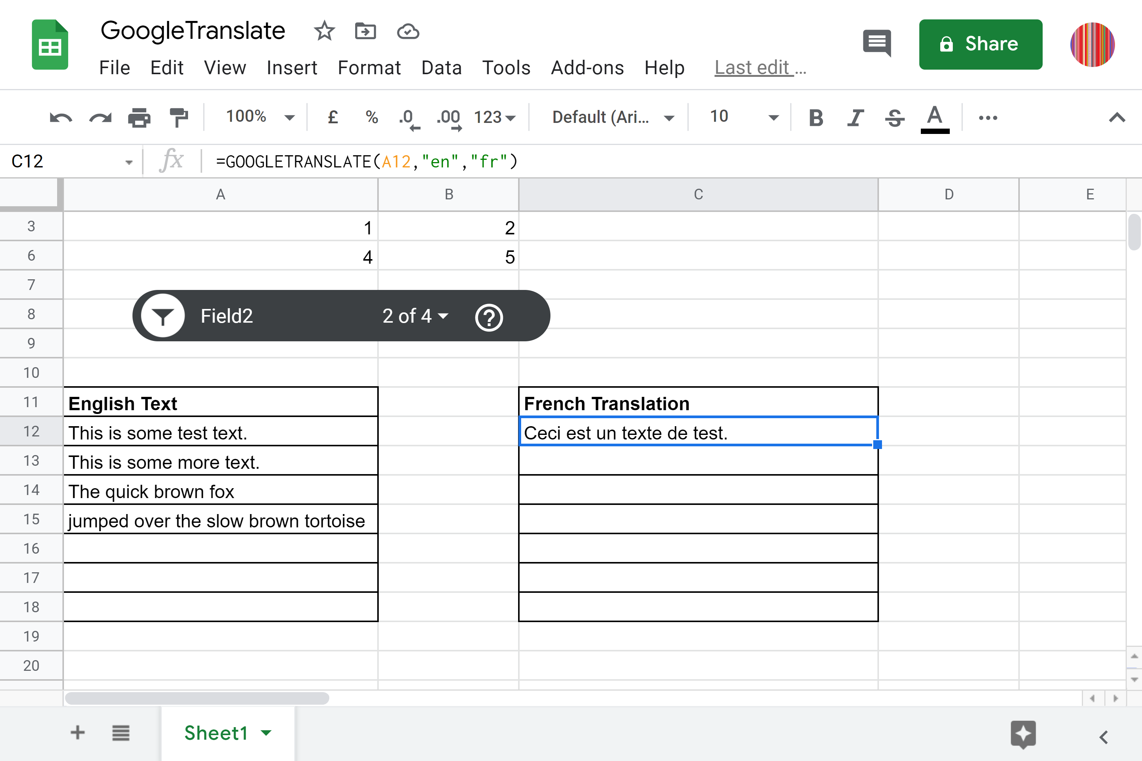

First thing to do is create the Translator Resource in Azure. Once done you copy the KEY 1 value as shown in this screenshot.

You should, then create the Office Scripts(s) that you need. You can’t create the Power Automate Flow without doing this first.

Here is how the solution presents in Excel Online. We have a table to the left where you input your English text and , automatically, the Flow runs and populates the cell immediately to the right with the translation. Two very small Office Scripts were needed to make this work.

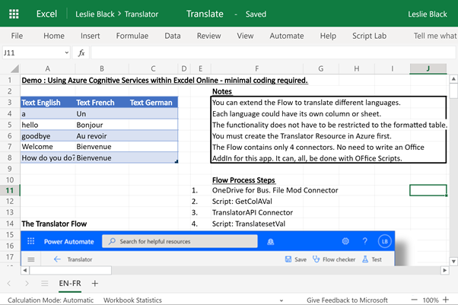

Here is the Flow including the two scripts and the “One Drive File Modifier” trigger together with Azure Translate API Connector. There are only four connectors , in total, for this solution! There are no conditional tests or loops needed!

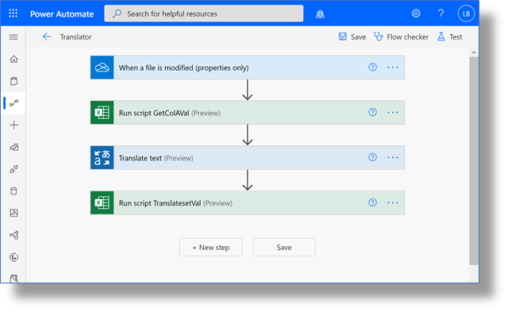

**Script: GetColAVal**

function main(workbook: ExcelScript.Workbook): string {

  //Get last cell value in column A - to translate.

  let ENFRSheet = workbook.getWorksheet('EN-FR')

  let Table1Range = ENFRSheet.getTable('Table1').getRangeBetweenHeaderAndTotal()

  let lastRow = Table1Range.getLastRow()

  let colAVal = lastRow.getValues()[0][0].toString()

  return colAVal

}

**Script: TranslatesetVal**

function main(workbook: ExcelScript.Workbook, returnVal:string) {

  //let returnVal:string = "Sometext"

  let ENFRSheet = workbook.getWorksheet('EN-FR')

  let Table1Range = ENFRSheet.getTable('Table1').getRangeBetweenHeaderAndTotal()

  let lastRow = Table1Range.getLastRow()

  let lastRowNo = lastRow.getRowIndex()

  ENFRSheet.getCell(lastRowNo,1).setValue(returnVal)

 }